PROJECT REPORT
ON

SCHOOL STAFF ATTENDANCE SYSTEM

Created By
1. Reshiya Ramesh
2. Jadav Jaydip
BSCIT – 5

Under The Guidance of
PROF. NIDHI PARMAR

Submitted To
GEETANAJALI COLLEGE OF COMPUTER SCIENCE & COMMERCE

Affiliated To
SAURASTRA UNIVERSITY
For Academic Year
2025-26
Acknowledgement

The project on SCHOOL STAFF ATTENDANCE SYSTEM is developed in PHP Language at GEETANJALI COLLEGE OF COMPUTER SCIENCE & COMMERCE.
I would like to acknowledge that my project has been completed and I am ensuring that, in this accomplishment, I would like to express my special gratitude to all my teachers and specially to PROF. NIDHI PARAMAR without their guidance and feedback it is not possible to complete this assignment.

Index

PERTICULARS | Page No.
- Introduction (Abstact 1,Purpose 1) | 1
- Project Profile | 2
- System Requiment | 3
- Models | 3
- Software Resources | 4
- Functionality | 4
- List Of Models | 5
- Data Dictonary | 5
- System Desine & Diagram
- DFD LEVEL 2 Diagram
- Use Case Diagram
- Table of Contant
- Images

INTRODUCTION

Abstract
The main objectives of this project are to manage and moniteor the daily attendance of school staff. The school staff attendance system is a managing staff attendance.it allows administrators to marks attendance attendance digitally,manage leaves,and generate reports efficiently.
Admin can add new user.

Purpose
- Accurate and timely attendance tracking.
- Reduction in administrative workload.
- Easy monitoring of staff punctuality and leave records.
- Generation of useful attendance reports for management.
- Improved transparency and accountability within the institution

Project Profile

Project Title: School Staff Attendance System
Development Software: Visual Studio Code
Front End Tool: HTML/CSS/BOOSTRAP
Back End Tool: PHP
Academic Year: 2025-26
Developed By: Reshiya Ramesh & Jadav Jaydip
Submitted To: SAURASTRA UNIVERSITY

System Requirements
- Server: Apache or any PHP-enabled web server
- Language: PHP (backend), HTML/CSS/JS (frontend)
- Database: MySQL/MariaDB
- Browser: Modern web browser

Modules
Admin Module: Manage staff, shifts, view reports, user management.
Staff Module: Mark attendance, view personal history, apply for leave.
Attendance Module: Record daily attendance, edit entries, import/export.3
Leave Management: Apply, approve/reject leaves, view leave balances.
Reports Module: Generatedaily/monthly/yearly attendance reports.
Authentication Module: Login, logout, session, role-based access control.

Software Resources
- Frontend Design Tool: Visual Studio Code
- Backend Design Tool: XAMPP (or WAMP / Laravel / Node.js)
- Code-Behind Language: PHP

Functionality
- User login and logout system
- Role-based access control (Admin / Staff)
- Add, edit, delete, and view staff details
- Mark daily attendance (by admin or self by staff)
- View and export attendance reports
- Manage departments and work shifts
- Apply for leave and manage leave requests
- View school calendar, holidays, and events
- Manage and view staff timetables
- Send and receive notifications
- View and update personal profile information
- Maintain database connection and configurations
- Generate audit logs and system reports

List of Modules
- Authentication Module
- Admin Dashboard Module
- Staff Management Module
- Attendance Management Module
- Department & Shift Management Module
- Leave Management Module
- Calendar & Timetable Module
- Notification Module
- Profile Management Module
- Database & Configuration Module

Data Dictionary

User Table(Login&Ragister)
columns | Datatype | Constraints
Id | Int (11) | Primary Key,Auto  Increment
Name | varchar (100) | Not null
Email | varchar (150) | Not null
Password | varchar (250) | Not null
Role | ENUM | Default `staff`
Department_id | Int (11) | Nullable(foreign key )
Shift_id | Int (11) | Nullable(foreign key )
Create_at | TIMESTAMP | Default ‘CURUNT_TIMESTAMP’
Profile_pic | Varchar (255) | Default ‘default.pnj’
Is_deleted | TINYINT(1) | Default 0(Active user)

Attendance Table
columns | Datatype | Constraints
Id | Int(11) | Primary Key,Auto Increment
User id | Int(11) | Not null
Date | date | Not null
Status | ENUM | Dedault ‘Absent’
Credited at | TIMESTAMP | CURUNT_TIMESTAMP

Leave Requset Table
columns | Datatype | Constraints
Id | Int(11) | Primary Key,Auto Increment
User id | Int(11) | Not null
Leave_type | varchar (250) | Not null
Start_date | date | Not null
End_date | date | Not null
Resion | text | Not null
Status | ENUM | Default ‘Pending’
Created_at | TIMESTAMP | CURUNT_TIMESTAMP

Department Table
columns | Datatype | Constraints
Id | int (11) | Primary Key,Auto Increment
name | varchar (100) | Not null

Shift Table
columns | Datatype | Constraints
id | int | Primary Key,Auto Increment
name | Varcher(100) | NOT null
Start time | time | Not null
End time | time | Not null

Notification Table:
columns | Datatype | Constraints
id | int (11) | PK,AI
title | Varcher(200) | NOT null
message | text | Not null
Target_role | ENUM | ALL
Created_by | Int(11) | Not null
Created_at | TIMSTAMP | CURUNT_TIMESTAMP

School_Calendar Table:
columns | Datatype | Constraints
id | int (11) | PK
title | Varcher(200) | NOT null
Event_date | date | Not null
Its_holiday | TINYINT(1) | 0
Notes | text | Not null
Created_at | TIMESTAMP | CURUNT_TIMESTAMP
Event_date | date | Not null

Timetable Table:
columns | Datatype | Constraints
id | int (11) | PK
User_id | int(11) | Not null
Day_of_week | ENUM | Null
Subject | varchar(100) | Null
Start_time | time | Null
End_time | time | Null

Audit_log Table
columns | Datatype | Constraints
id | int | Primary Key,Auto Increment
User_id | Varcher(100) | Not null
Action | Varchar(255) | Not null
Meta | Text | Null
Created_at | TIMESTAMP | CURUNT_TIMESTAMP

System Designe & Diagram
Data Flow Diagram Symbol
Symbol | Description
 | Data Flow – Data flow are pipelines through the packets of information flow.
 | Process : A Process or task performed by the system.
 | Entity : Entity are object of the system. A source or destination data of a system.
 | Data Store : A place where data to be stored.

ERD [Entity Relationship Diagram]

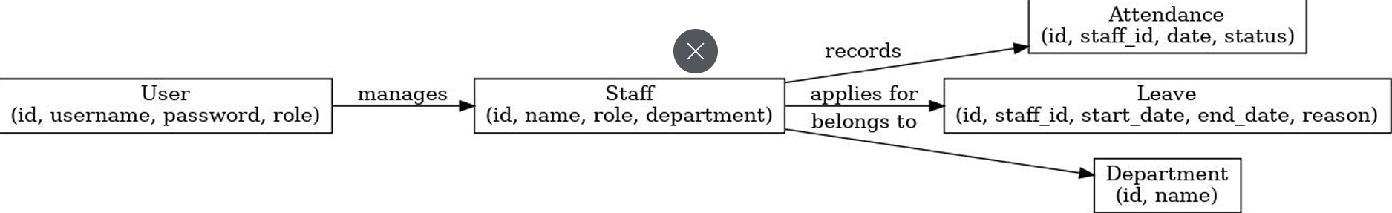

0 level DFD (Context Diagram)
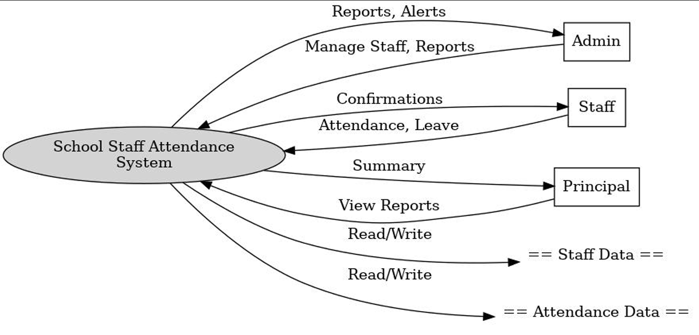
STAFF

Level 1 DFD

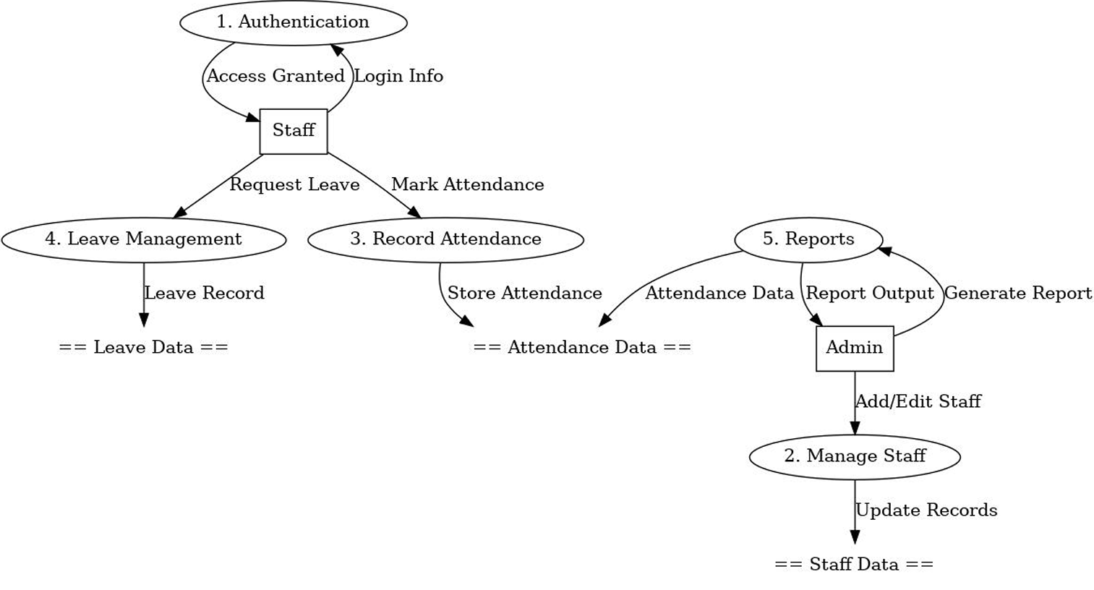

Use Case Diagram

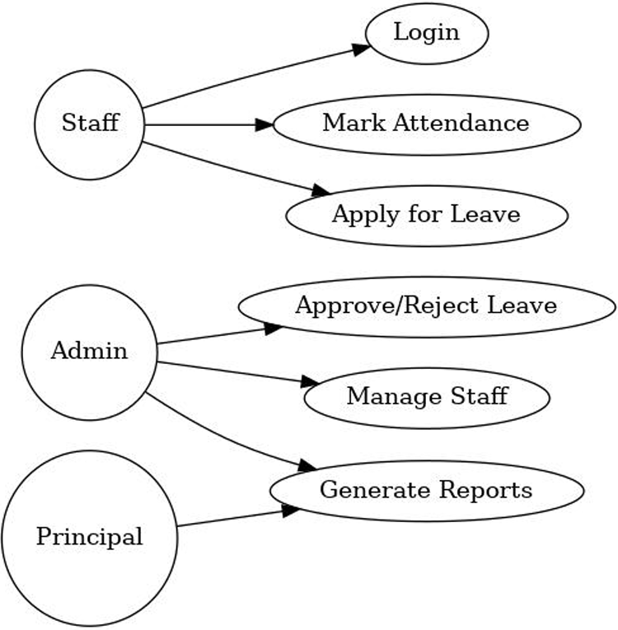
STAFF
ADMIN

ADMIN
D
A
T
A
B
A
S
E

Table of Contents
1. Authentication
2. Admin Dashboard
3. Staff Management
4. Attendance Management
5. Department & Shift Management
6. Leave Management
7. Notifications Management
8. Profile Management
9. School Calendar & Events

Authentication
Test NO. | Test Scenario | Expected Result | Status
1 | Verify module main page loads successfully. | Page should load without errors | Successful
2 | Verify user input validations. | System should validate and show proper messages | Successful
3 | Verify authorized access control. | Unauthorized users should not access restricted pages | Successful
4 | Verify CRUD operations work correctly. | Create, Update, Delete actions should function properly | Successful
5 | Verify UI and layout responsiveness. | Page layout should be responsive on all devices | Successful

Admin Dashboard
Test NO. | Test Scenario | Expected Result | Status
1 | Verify module main page loads successfully | Page should load without errors | Successful
2 | Verify user input validations. | System should validate and show proper messages | Successful
3 | Verify authorized access control. | Unauthorized users should not access restricted pages | Successful
4 | Verify CRUD operations work correctly. | Create, Update, Delete actions should function properly | Successful
5 | Verify UI and layout responsiveness. | Page layout should be responsive on all devices | Successful

Staff Management
- Test NO. | Test Scenario | Expected Result | Status
1 | Verify module main page loads successfully | Page should load without errors | Successful
2 | Verify user input validations. | System should validate and show proper messages | Successful
3 | Verify authorized access control. | Unauthorized users should not access restricted pages | Successful
4 | Verify CRUD operations work correctly. | Create, Update, Delete actions should function properly | Successful
5 | Verify UI and layout responsiveness. | Page layout should be responsive on all devices | Successful

Attendance Management
Test NO. | Test Scenario | Expected Result | Status
1 | Verify module main page loads successfully | Page should load without errors | Successful
2 | Verify user input validations. | System should validate and show proper messages | Successful
3 | Verify authorized access control. | Unauthorized users should not access restricted pages | Successful
4 | Verify CRUD operations work correctly. | Create, Update, Delete actions should function properly | Successful
5 | Verify UI and layout responsiveness. | Page layout should be responsive on all devices | Successful

Department & Shift Management
Test NO. | Test Scenario | Expected Result | Status
1 | Verify module main page loads successfully | Page should load without errors | Successful
2 | Verify user input validations. | System should validate and show proper messages | Successful
3 | Verify authorized access control. | Unauthorized users should not access restricted pages | Successful
4 | Verify CRUD operations work correctly. | Create, Update, Delete actions should function properly | Successful
5 | Verify UI and layout responsiveness. | Page layout should be responsive on all devices | Successful

Leave Management
Test NO. | Test Scenario | Expected Result | Status
1 | Verify module main page loads successfully | Page should load without errors | Successful
2 | Verify user input validations. | System should validate and show proper messages | Successful
3 | Verify authorized access control. | Unauthorized users should not access restricted pages | Successful
4 | Verify CRUD operations work correctly. | Create, Update, Delete actions should function properly | Successful
5 | Verify UI and layout responsiveness. | Page layout should be responsive on all devices | Successful

Notifications Management
Test NO. | Test Scenario | Expected Result | Status
1 | Verify module main page loads successfully | Page should load without errors | Successful
2 | Verify user input validations. | System should validate and show proper messages | Successful
3 | Verify authorized access control. | Unauthorized users should not access restricted pages | Successful
4 | Verify CRUD operations work correctly. | Create, Update, Delete actions should function properly | Successful
5 | Verify UI and layout responsiveness. | Page layout should be responsive on all devices | Successful

Profile Management
Test NO. | Test Scenario | Expected Result | Status
1 | Verify module main page loads successfully | Page should load without errors | Successful
2 | Verify user input validations. | System should validate and show proper messages | Successful
3 | Verify authorized access control. | Unauthorized users should not access restricted pages | Successful
4 | Verify CRUD operations work correctly. | Create, Update, Delete actions should function properly | Successful
5 | Verify UI and layout responsiveness. | Page layout should be responsive on all devices | Successful

School Calendar & Event
Test NO. | Test Scenario | Expected Result | Status
1 | Verify module main page loads successfully | Page should load without errors | Successful
2 | Verify user input validations. | System should validate and show proper messages | Successful
3 | Verify authorized access control. | Unauthorized users should not access restricted pages | Successful
4 | Verify CRUD operations work correctly. | Create, Update, Delete actions should function properly | Successful
5 | Verify UI and layout responsiveness. | Page layout should be responsive on all devices | Successful

- Login Screen:

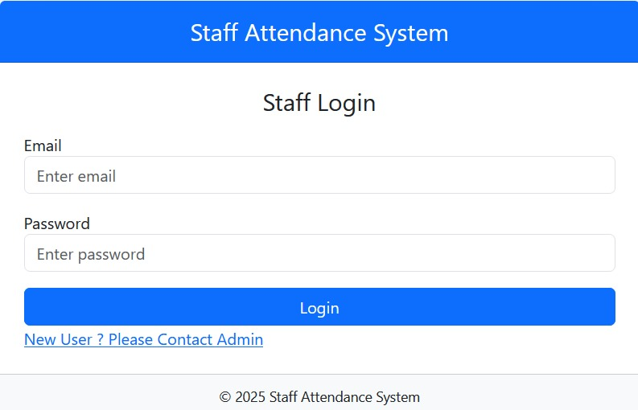

→ In this page user must give username & password.
→ If the password is correct, then he will be redirect to home page else he gets the prompt.
→ If the user forgot the password, then he will be able to change his password from this page.

- Admin Dashbord page:

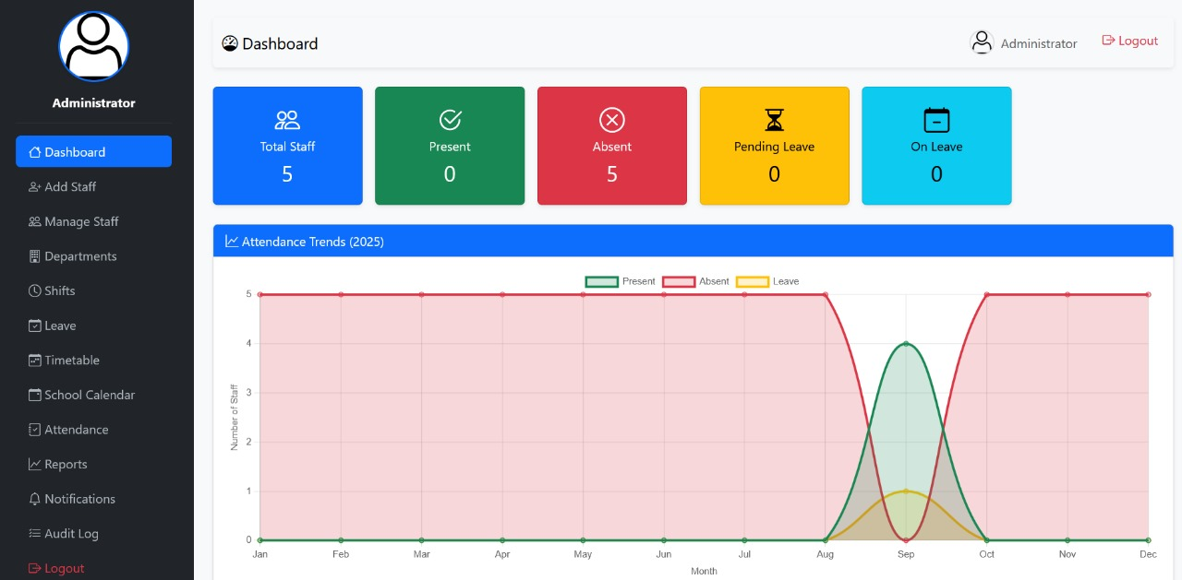

- Hear is a admin dashboard to show all data and information.
- Admin can add a staff and managing all staff and Activity.
- Hear is admin can handal all staff,staff leave,staff time tabale,staff attendance or notifications.
- Admin can add staff.
- Admin can approve a staff attendance and leave.

- Staff Home Page:
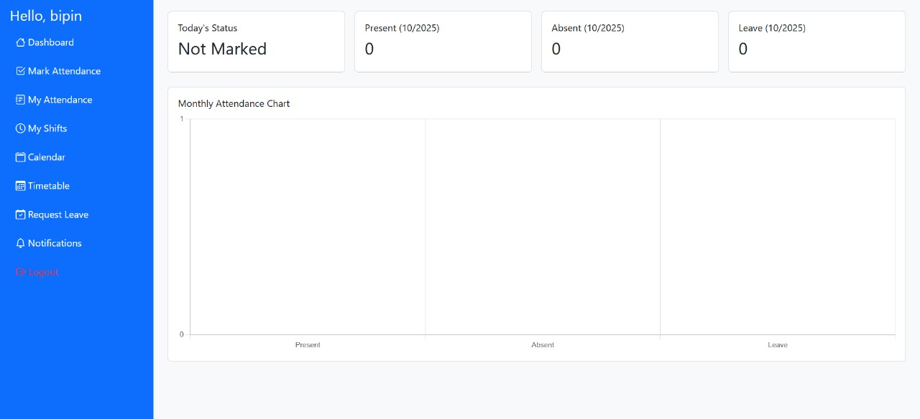

- Hear is a staff dashboard ,staff can mark is attendance.
- Staff can see his attendance.
- Request leave option,staff can submit hear leave request.
- Notification is avalabal ,staff is see all admin notification like school evnt,staff metting,holiday etc.
- Timetabale to show school time tabale.

- Staff Add & Edit Page:

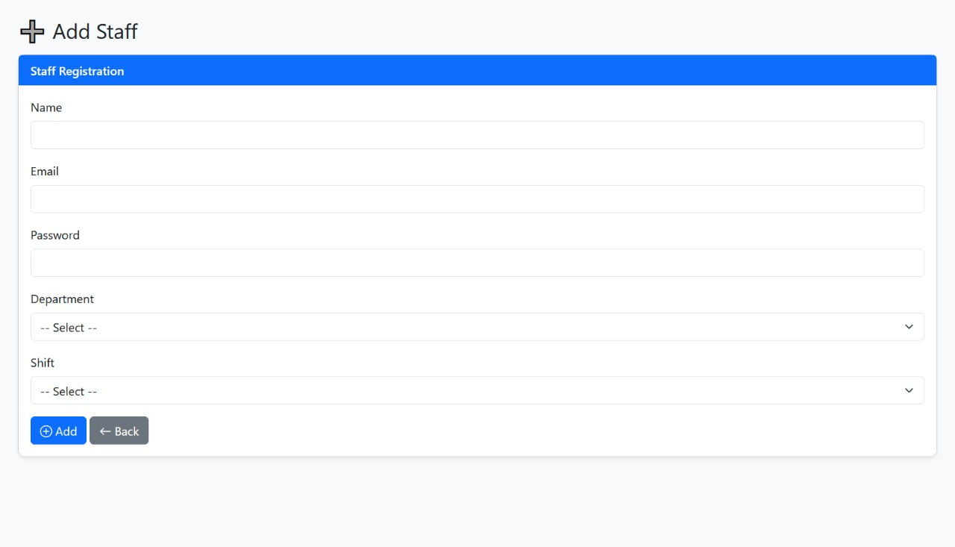

- Hear is a page to add a new staff.
- Staff information like name,email,password fulfil.
- After department selected and full fill information.
- After a click a add staff,and New staff is add.you
- This page is use to new staff member are add.

- Mark Attendance Page:
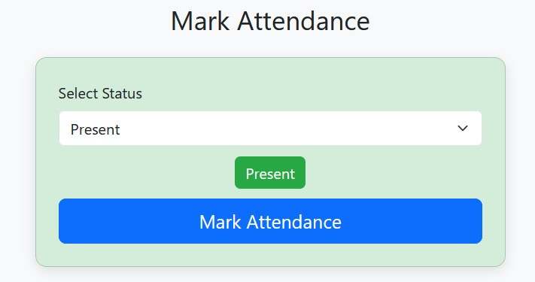

- In this page user can take attendance of teacher.
- Mark attendance page mark a staff attendance.
- Staff are mark they attendance this page.
- 24hours you can no chose present, they are automatically absentmark.

➢ Attendance Report page:
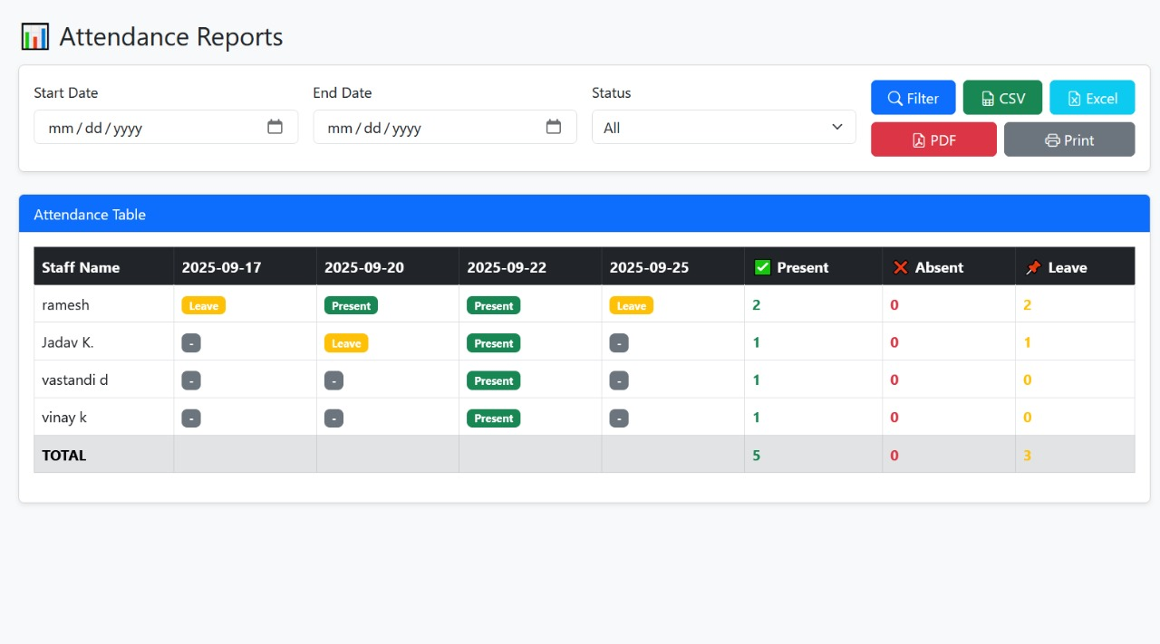

- School staff attendance report is official record that tracks the present,absenet and leave of staff members within a specific period.
- School staff attendance report is all data and information are showing.
- Back dashbord is used for go back to home page.

- Request Leave page:
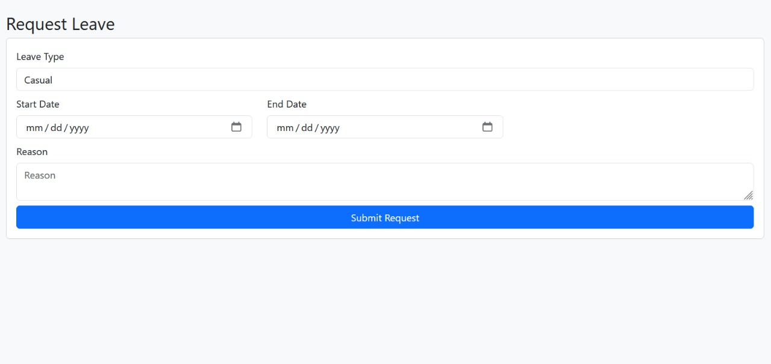

- In this page staff enter a leave request.
- Hire is show a leave a type ,and start date to end date.
- you enter your reson,why are you leave ex.sick leave,medical,marriage etc.
- And last is submit your leave reqest.

